# **FILE & FOLDER EXERCISES**

## ACTIVITY 1

1. Open the folder FILES

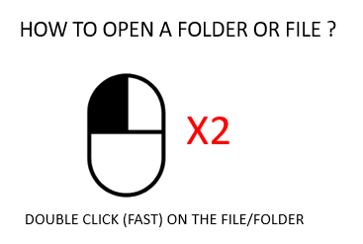

1. You should see a list of files:

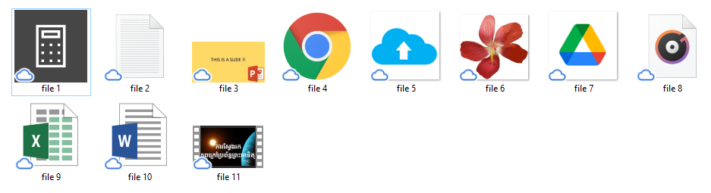

1. **Open** each file and **complete** the below table

|  |  |  |
| --- | --- | --- |
| FILE | WHAT IS THE TYPE OF THE FILE  **IMAGE / SOUND** / **DOCUMENT / APPLICATION** | NAME OF APPLICATION  TO OPEN |
| File 1 |  |  |
| File 2 |  |  |
| File 3 |  |  |
| File 4 |  |  |
| File 5 |  |  |
| File 6 |  |  |
| File 7 |  |  |
| File 8 |  |  |
| File 9 |  |  |
| File 10 |  |  |

## ACTIVITY 2

Complete the table

* Write the **extension** of the file
* Write the **date of creation** of the file
* Do you think the TYPE of file is related to the EXTENSION of the file?

|  |  |  |
| --- | --- | --- |
| FILE | **EXTENSION** OF THE FILE | **DATE OF MODIFICATION** |
| File 5 |  |  |
| File 6 |  |  |
| File 10 |  |  |
| File 1 |  |  |

## ACTIVITY 3

1. **Create the following folders**
   * IMAGE
     + PNG­
     + JPG
   * SOUND
   * DOCUMENT
   * APPLICATION
2. Given the types of files you found in exercise 1, **Move the files** to the appropriate **folder**

## ACTIVITY 4

1. Create a new folder named: MY-DATA
2. **Move** the file1 into this folder

* Check that file1 does not exist anymore in the folder FILES

1. **Copy** the file2 to this folder

* **WARNING**: Copy is not MOVE! You need to COPY + PASTE:
* Check the file2 still exists in the folder FILES

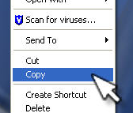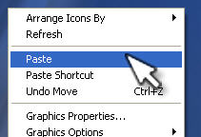

STEP 1: **COPY** THE FILE STEP2: **PASTE** THE FILE

1. Rename this file: **myFile**
2. Open this file using **NOTEPAD**
3. Edit the file
4. Save and quit
5. Open again and check your changes are still in the file
6. Remove the file **file2** (not your copy, but the original file)

Files

Media_Files

Photo_files

Photo1

photo2

photo3

Sound_Files

music

Execute_Files

application.exe

Document_Files

test

note

slide

## ACTIVITY 5

1. See the above diagram
2. Create folders and set their location owing to their hierarchy in the diagram.
3. Rename the folders to the names in the diagram.
4. Copy files from the folder named “FILES_EXCERCISE5”, and put in folders owing to their type.
5. Rename the file‘s name owing to their name in the diagram. For example photo1.